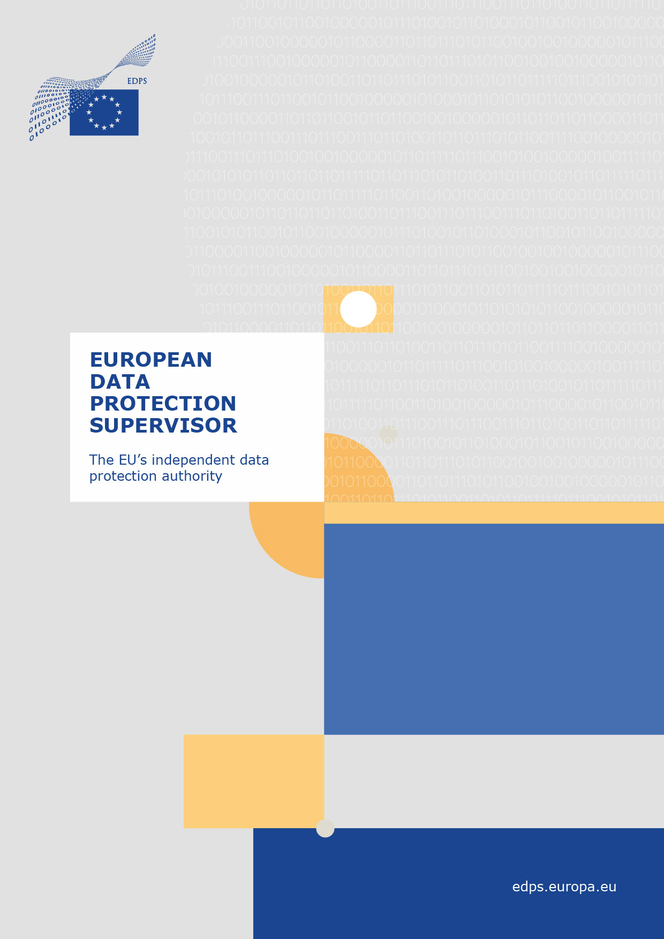
19 December 2022
Opinion 27/2022
on the Proposal for a Regulation amending Regulations (EU) No 260/2012 and (EU) 2021/1230 as regards instant credit transfers in euro
The European Data Protection Supervisor (EDPS) is an independent institution of the EU, responsible under Article 52(2) of Regulation 2018/1725 ‘With respect to the processing of personal data… for ensuring that the fundamental rights and freedoms of natural persons, and in particular their right to data protection, are respected by Union institutions and bodies’, and under Article 52(3)‘…for advising Union institutions and bodies and data subjects on all matters concerning the processing of personal data’.
Wojciech Rafał Wiewiórowski was appointed as Supervisor on 5 December 2019 for a term of five years.
Under Article 42(1) of Regulation 2018/1725, the Commission shall ‘following the adoption of proposals for a legislative act, of recommendations or of proposals to the Council pursuant to Article 218 TFEU or when preparing delegated acts or implementing acts, consult the EDPS where there is an impact on the protection of individuals’ rights and freedoms with regard to the processing of personal data’.
This Opinion relates to [insert full name of the legislative Proposal or Recommendation or Proposal to the Council Pursuant to Article 218 TFEU].This Opinion does not preclude any future additional comments or recommendations by the EDPS, in particular if further issues are identified or new information becomes available. Furthermore, this Opinion is without prejudice to any future action that may be taken by the EDPS in the exercise of his powers pursuant to Regulation (EU) 2018/1725. This Opinion is limited to the provisions of the draft Proposal that are relevant from a data protection perspective.

  - Executive Summary
  - On 26 October 2022 the European Commission issued a Proposal for a Regulation of the European Parliament and of the Council amending Regulations (EU) No 260/2012 and (EU) 2021/1230 as regards instant credit transfers in euro.
  - The objective of the Proposal is to improve the low uptake of euro instant credit transfers to allow for their benefits to realise, including efficiency gains for consumers, merchants, corporate users, payment service providers and financial technology companies, and public administrations including tax authorities. A second objective is to extend the means of payment at points of interaction, particularly for cross-border transactions. At the end of 2021, only 11% of euro credit transfers sent in the EU were instant payments, although the architecture for instant payments in euro already exists, inter alia with the Single Euro Payments Area (SEPA) instant credit transfer scheme of 2017.
  - From the problems addressed by the Proposal, two are of particular relevance to data protection: To address concerns by payers about the security of instant payments, the Proposal would oblige payment service providers to verify whether the payment account identifier and the name of the payee provided by the payer match, prior to authorization of the payment by the payer. Where they do not match, the payment service provider shall notify the payer of any discrepancies detected and the degree of any such discrepancy. The EDPS welcomes the Proposal and in particular the proposed matching that would give payers the chance to compare their data with the response from the system and make informed decisions whether it is safe to authorise the payment. Where this security feature is not needed, the Proposal gives payers the possibility to opt-out, thus leading to less processing of personal data.
  - Under the current legislation, a high rate of rejected instant payments is caused by wrongly identifying persons who are involved in the instant credit transfer as persons on EU sanctions lists. The Proposal provides for a requirement for sanctions screening in the form of very frequent checking of clients against EU sanctions lists, rather than for each individual transaction, to avoid the false positives. The EDPS welcomes that the Proposal would direct the practice to a periodic verification method that can be executed with the necessary diligence, so that false positives can be avoided and data subjects do not experience unwarranted payment refusals.
  - The EDPS does not have any observations relating to the remaining provisions of the Proposal.

Contents
1. Introduction 4
2. General remarks 5
3. Verification of discrepancies between the name and payment account identifier of a payee in case of instant credit transfers 5
4. Screening of payment services users with regard to Union sanctions in case of instant credit transfers 6
5. Conclusions 6

THE EUROPEAN DATA PROTECTION SUPERVISOR,
Having regard to the Treaty on the Functioning of the European Union,
Having regard to Regulation (EU) No 2018/1725 of the European Parliament and of the Council of 23 October2018 on the protection of individuals with regard to the processing of personal data by the Community institutions and bodies and on the free movement of such data (‘EUDPR’), and in particular Article 42(1) thereof,

HAS ADOPTED THE FOLLOWING OPINION:

Introduction
- On 26 October 2022 the European Commission issued a Proposal for a Regulation of the European Parliament and of the Council amending Regulations (EU) No 260/2012 and (EU) 2021/1230 as regards instant credit transfers in euro.
- The objective of the Proposal is to improve the low uptake of euro instant credit transfers to allow for their benefits to realise, including efficiency gains for consumers, merchants, corporate users, payment service providers and financial technology companies, and public administrations including tax authorities. A second objective is to extend the means of payment at points of interaction, particularly for cross-border transactions.
- Two EU legal acts in the field of payments, the 2015 Directive on payment services in the internal market (PSD2) and the Regulation on cross-border payments, already apply to instant payments and will continue to do so after the entry into force of this proposal. However, the SEPA Regulation was chosen by the Commission to host the new provisions as it lays down technical and business requirements for all credit transfers in euro and instant payments in euro are a new category of credit transfers in euro.
- The present Opinion of the EDPS is issued in response to a consultation by the European Commission of 27 October 2022, pursuant to Article 42(1) of EUDPR. The EDPS welcomes the reference to this consultation in Recital 23 of the Proposal.

General remarks
- According to the legislative memorandum, the Commission has identified four problem drivers that are being addressed by the Proposal, among them also two that relate to data protection: under the current legislation, a high rate of rejected instant payments is caused by wrongly identifying persons who are involved in the transfer as persons on EU sanctions lists. The Proposal provides for a requirement for sanctions screening in the form of very frequent checking of clients against EU sanctions lists, rather than for each individual transaction, to avoid the false positives. This also implies that the required data processing will occur without the persons concerned having provided a reason for the verification, e.g. by initiating an instant payment.
- Secondly, payers are concerned about the security of instant payments. The Proposal aims to address this problem driver by requiring the payment service providers to offer a service enabling customers to be notified prior to authorising the instant credit transfer when a mismatch is detected between the payee’s name and international bank account number (IBAN), as supplied by the payer. Payment service providers are therefore required to verify the discrepancies between the name and payment account identifier of the payee in case of euro IPs, thus to process additional data.
- The current Opinion will focus on these two measures with data protection relevance, as laid down in the new Article 5c and new Article 5d of Regulation (EU) No 260/2012.
- The EDPS welcomes the reference to the GDPR in Recital 21.

Verification of discrepancies between the name and payment account identifier of a payee in case of instant credit transfers

- The proposed Article 5c of the SEPA Regulation would oblige payment service providers to verify whether the payment account identifier and the name of the payee provided by the payer match. Where they do not match, that payment service provider shall notify the payer of any discrepancies detected and the degree of any such discrepancy.
- The EDPS recalls that banks require the payer to provide the name of the payee for other purposes, e.g. compliance. The data collected will therefore be the same. But the payment service providers offering instant credit transfers will now jointly have to verify the payer’s information about the payee in automated form and present discrepancies to the payer. The EDPS recognizes that this is additional processing of the personal data of the payee, however he is of the opinion that it is justified by its purpose to give assurance that an instant credit transfer will reach the person it is intended for.
- The EDPS further welcomes that this service is offered with a possibility to opt-out and to opt-in again, so that the payment service user can limit the processing to what he or she deems necessary. That only users receiving the service can opt-out and not users who receive funds and whose data are processed is a cogent consequence of the purposes of this processing and does not render the processing disproportionate.

Screening of payment services users with regard to Union sanctions in case of instant credit transfers
- The proposed Article 5d(1) of Regulation (EU) No 260/2012 would provide for an obligation for payment service providers to verify immediately after the entry into force of any new or amended restrictive measures adopted in accordance with Article 215 TFEU providing for asset freeze or prohibition of making funds or economic resources available, whether any of their payment services users are listed persons or entities. Additionally, this verification would have to be carried out at least once every calendar day.
- On the other hand, verifications during the execution of an instant credit transfer should not take place.
- The EDPS takes note of the balancing undertaken by the Commission between the need to implement the sanctions regime and the efficiency of the payment system. He further takes note that the current system does not allow for manual verification of false hits in case of instant credit transfers, leading to unfounded refusals of payments and faulty processing of personal data. Therefore, the EDPS welcomes the abandonment of the existing verification practice by the Proposal.
- The methodology of recurrent checks irrespective of any instant credit transfers undertaken by the users concerned is further explained in Recitals 14 and 15 and does not raise particular data protection concerns. To prevent the initiation of instant credit transfers from payment accounts belonging to listed persons or entities and to immediately freeze funds sent to such accounts, it is the professional assessment that short intervals of no more than a day are necessary. The EDPS has no indication to the contrary.
- Lastly, the EDPS takes note that the Proposal would also put an end to diverging practices in Member States and install a transparent procedure to ensure that payment service providers comply with their obligations stemming from Union sanctions. The EDPS welcomes this contribution to legal certainty.

Conclusions
- In light of the above, the EDPS welcomes the measures provided for by the Proposal to verify data of a payee and to abstain from checking payment service users during an instant credit transfer.
- The compensatory regular verification with the EU sanctions lists, irrespective of a concrete transaction, does not raise any concerns.

Brussels, 19 December 2022
(e-signed)
Wojciech Rafał WIEWIÓROWSKI

OJ L 295, 21.11.2018, p. 39.
Directive (EU) 2015/2366 of the European Parliament and of the Council of 25 November 2015 on payment services in the internal market.
Regulation (EU) 2021/1230 of the European Parliament and of the Council of 14 July 2021 on cross-border payments in the Union (codification).
Regulation (EU) No 260/2012 of the European Parliament and of the Council of 14 March 2012 establishing technical and business requirements for credit transfers and direct debits in euro.

